Local repository: A repository(Project) which is available at local system and it is ready to go to the git server.

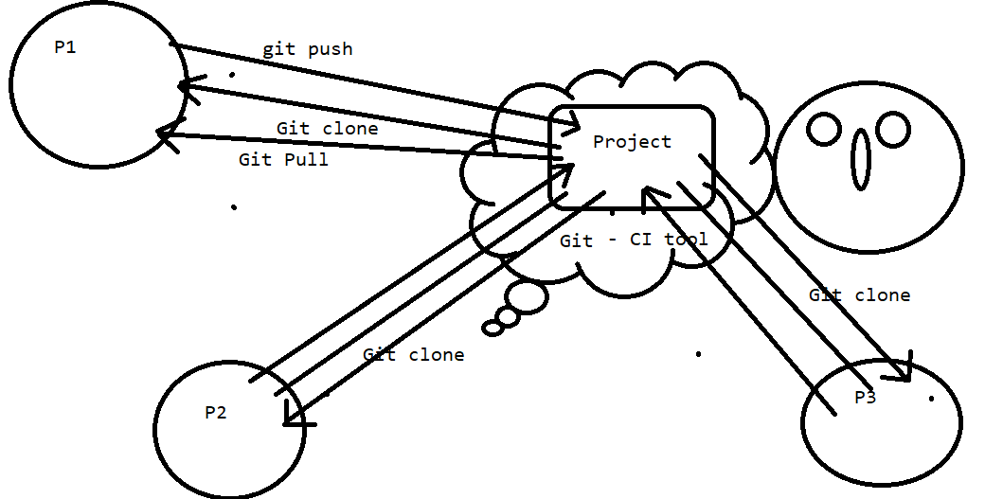

Commands in git:

1. Add: to add the files which wants to put into the git server.

2. commit: Through this command we are moving our code to the staging area.

3. push: to push the code to the git.

4. pull: To take the latest updated code into the system we have to perform pull command.

5. clone: This command is used to take the code from git repository to local repository for the first time.

Git configuration:

Step 1: Create a new repository by clicking on ‘+’ or click on green button.

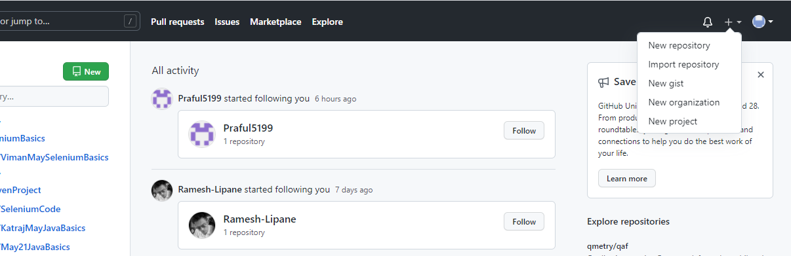

Step 2: Fill the details and click on create repository:

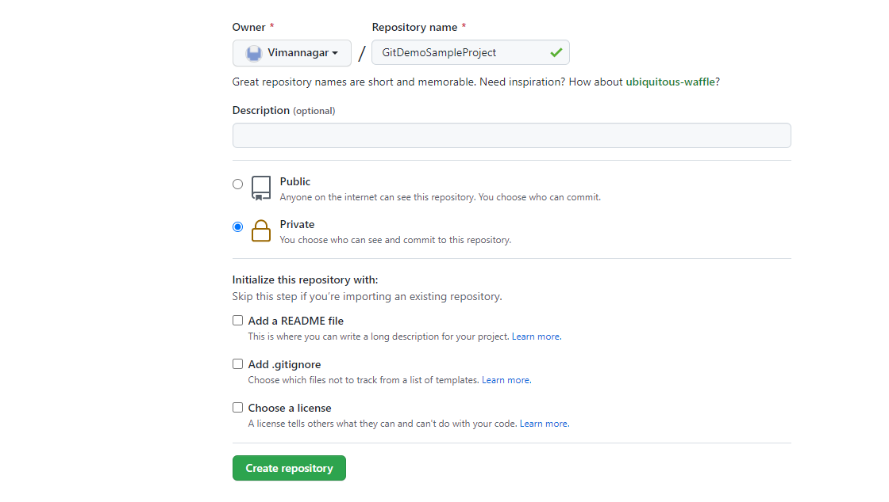

After the creation ofgit repository we need to copy the url

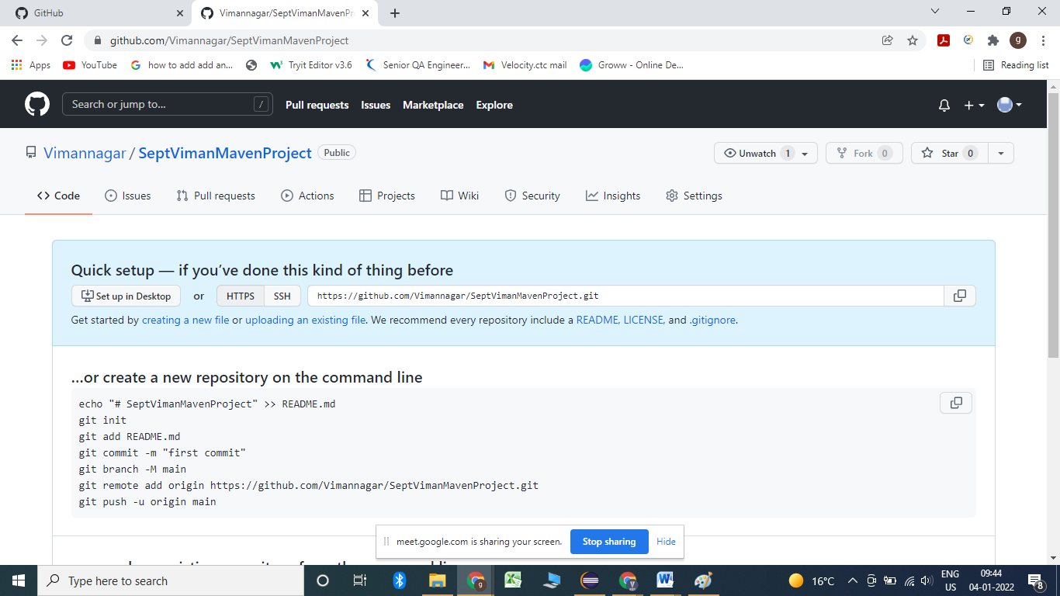

Step 3: Go to eclipse and right click on the project which we wants to push over the git server and select team --- share project.

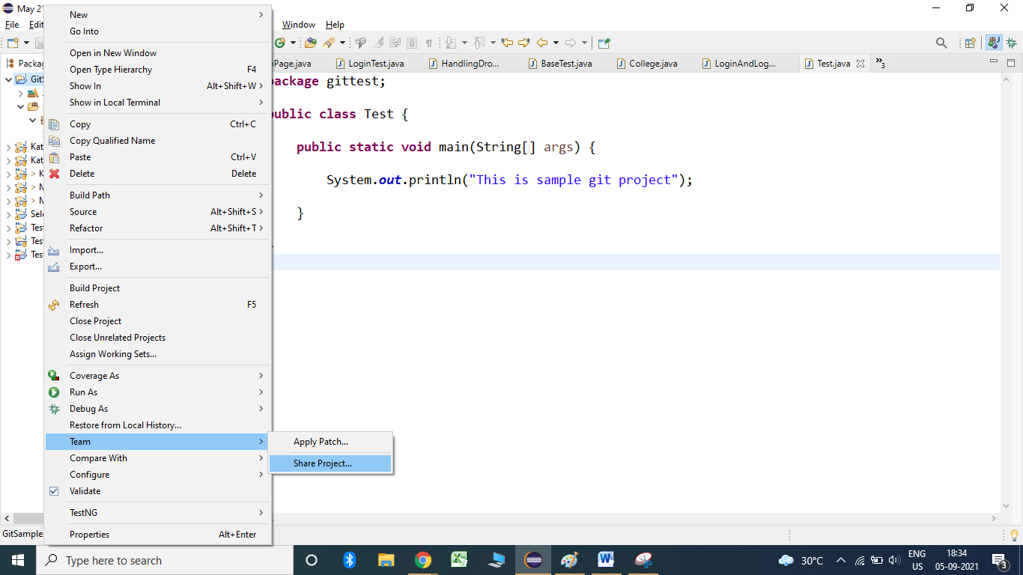

Step 4: Click on the share project click on the check box of below dialogue box and click on the project check box as well and click on create repository and click on finish.

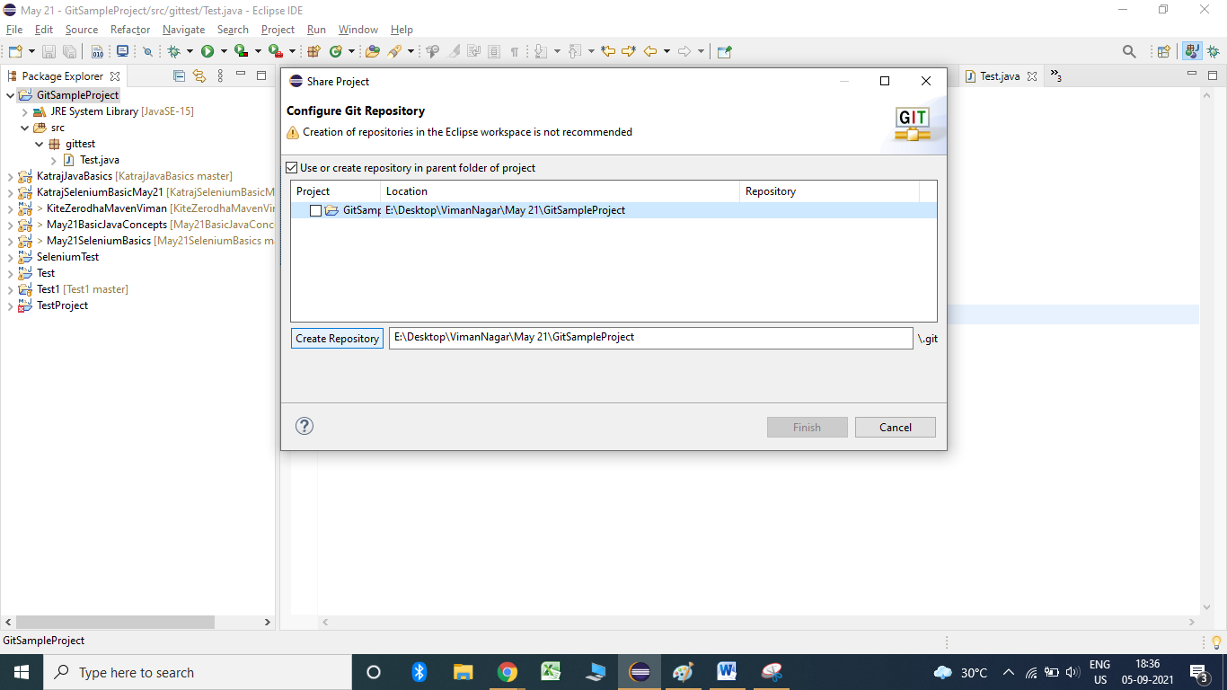

Step 5: To add the newly created files/updated files we have to perform add operation.

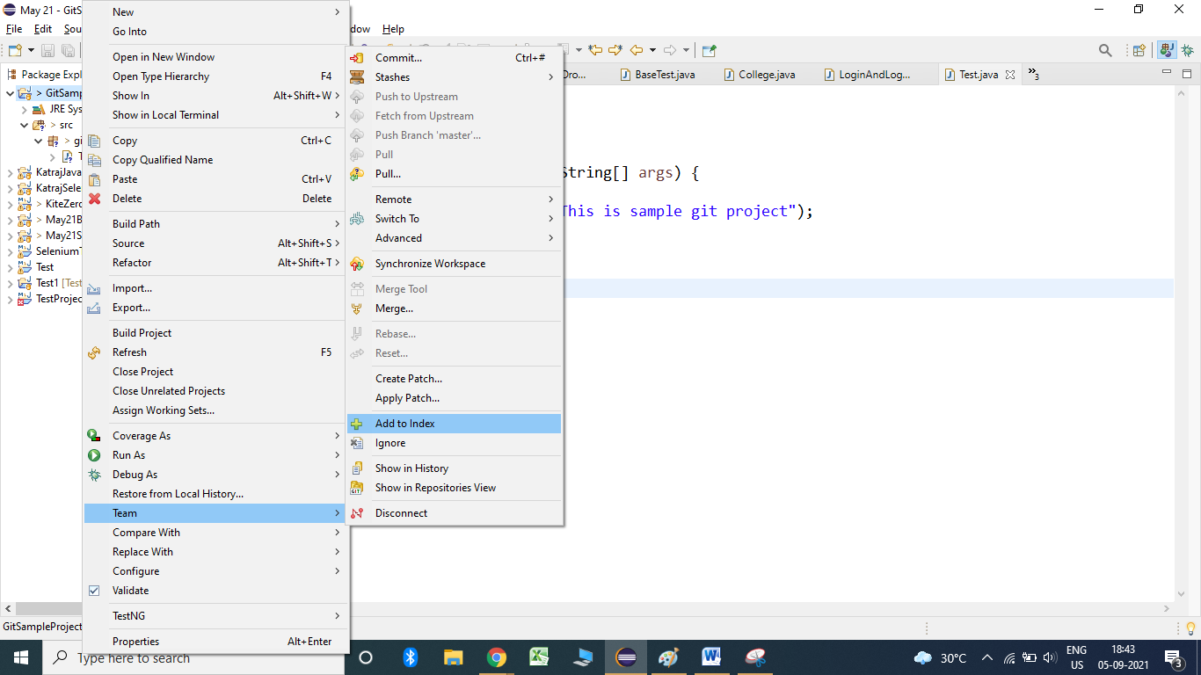

Step 6: to commit the project right click on project --- Team--- commit

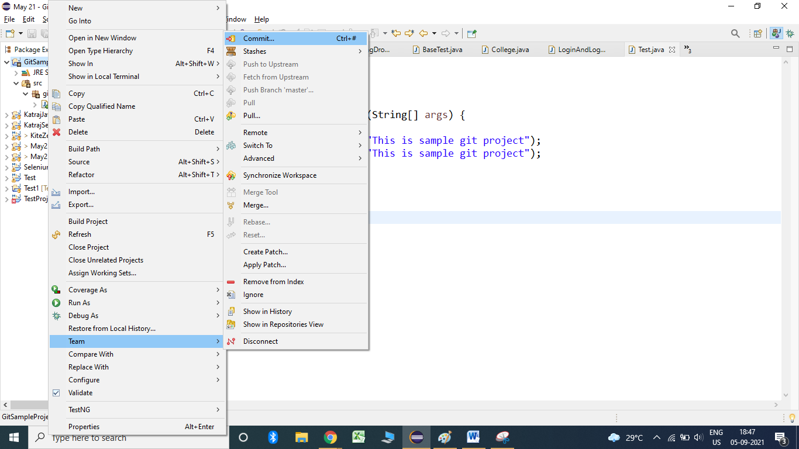

Step 7: Write down the message for the commit process and click on commit.

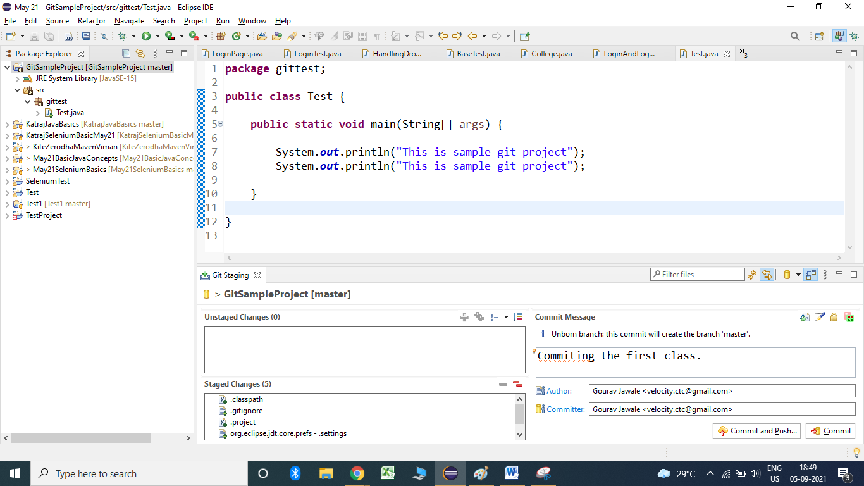

Step 8: To push code Right click on project --- Team--- push.

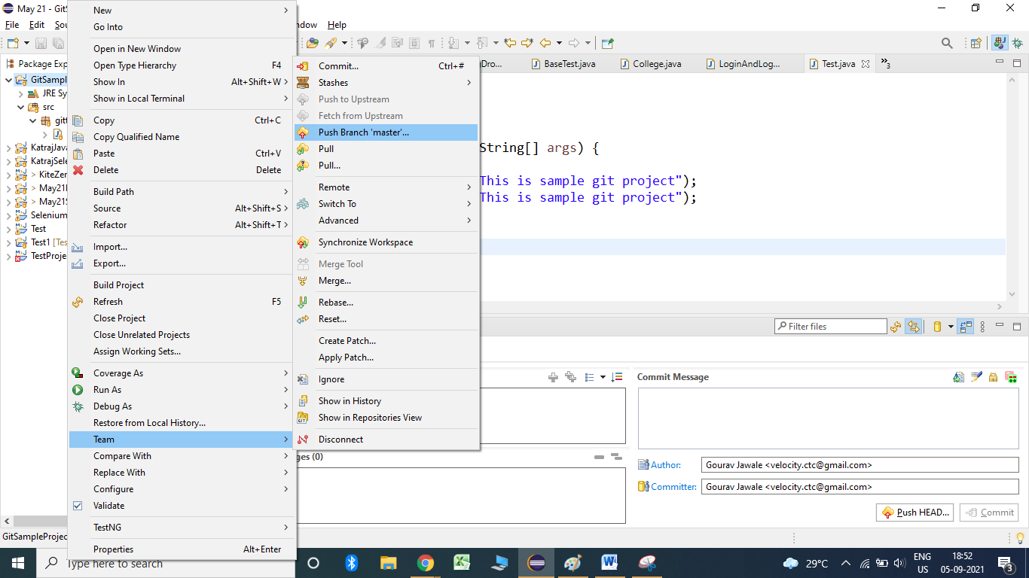

Step 9: Paste the url from the git into the URI path and enter the username into the field.

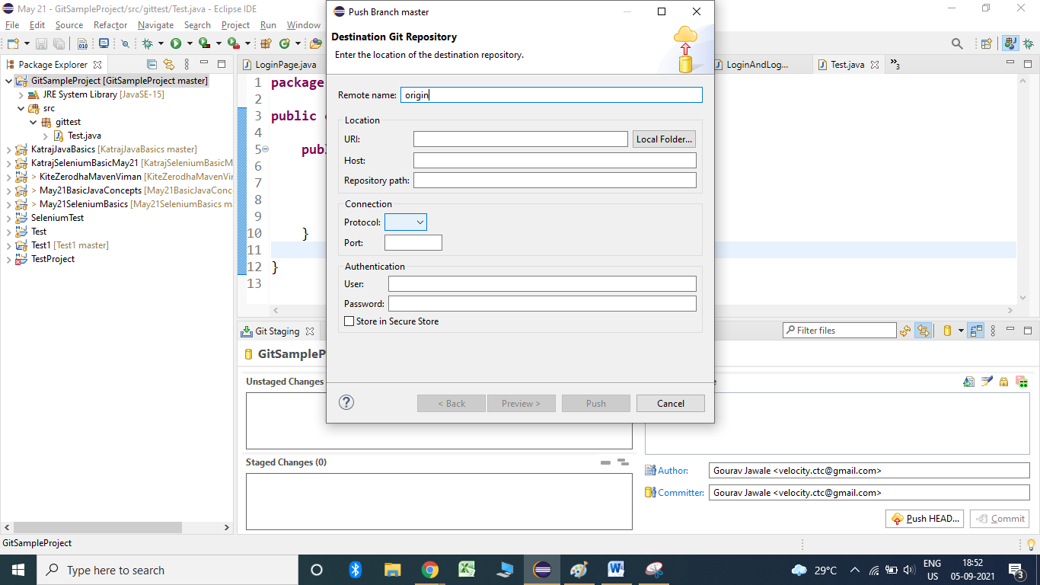

Step 10: Generate the personal access token from git account that has to be used for password.

To generate the token:

1. click on the profile avatar and select settings:

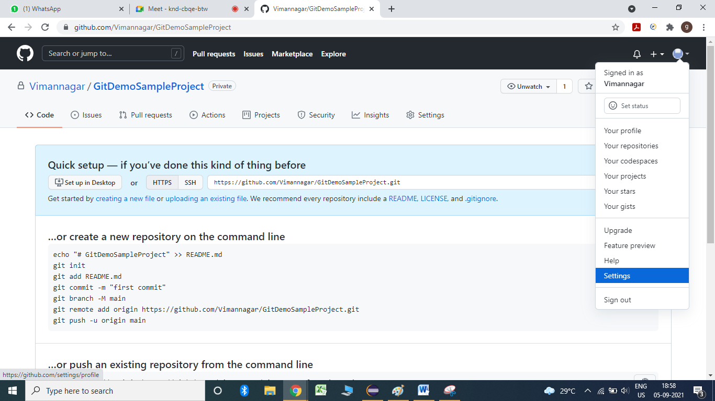

2. Click on developer setting:

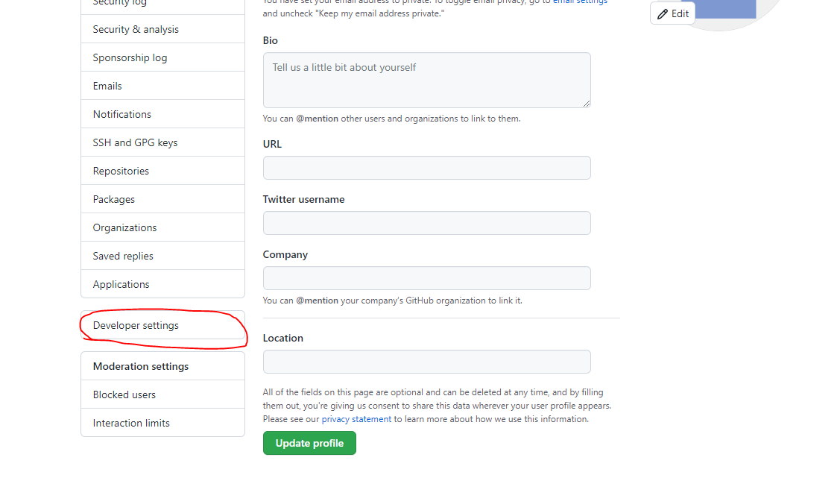

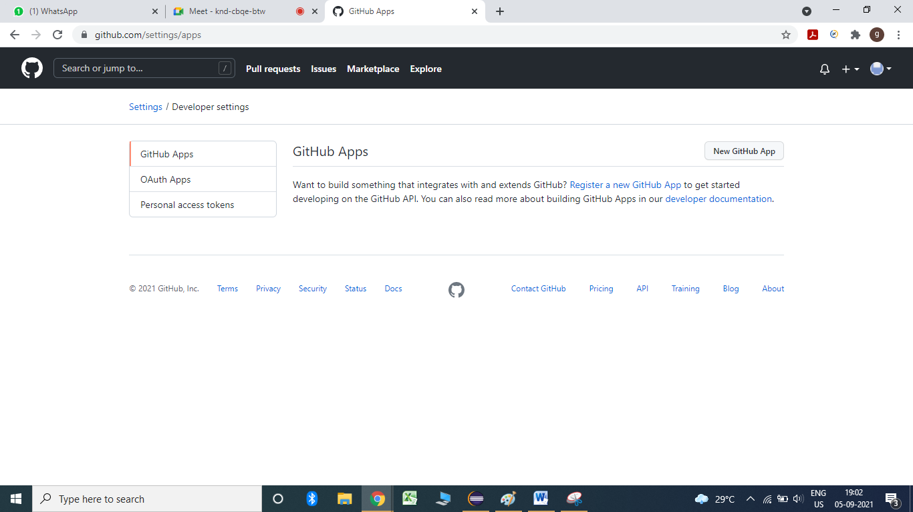

3. Click on personal access token:

4. Click on generate new token.

5. After the generation of new token right click on the project—Team—Push to branch master:

Paste the url and enter the username of git and personal access token as password followed by click on secure storage check box.

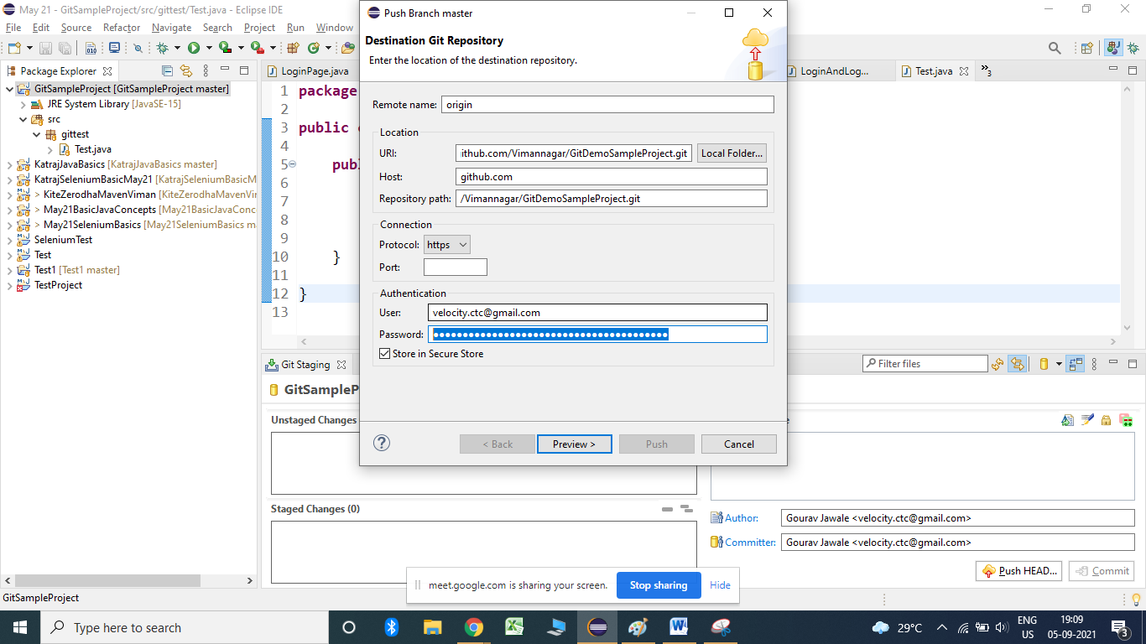

Click on the preview button and click on Push.

To provide acess to the user:

Click on settings in the git hub and click on Manage access:

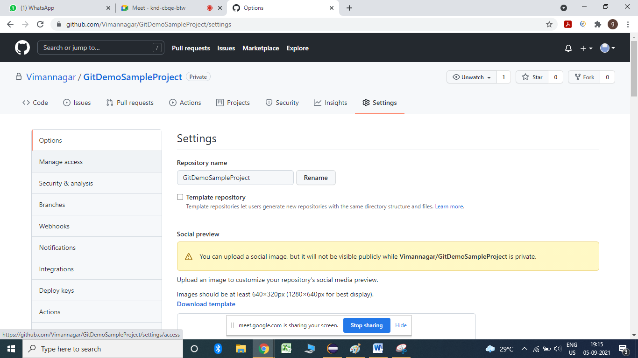

Clone a git project:

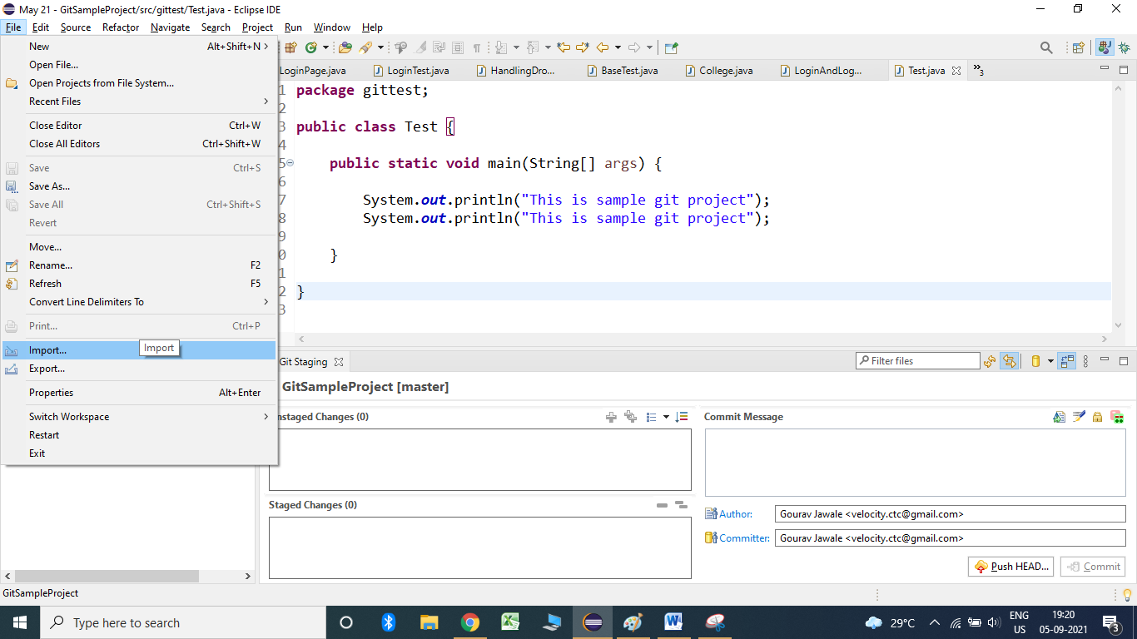

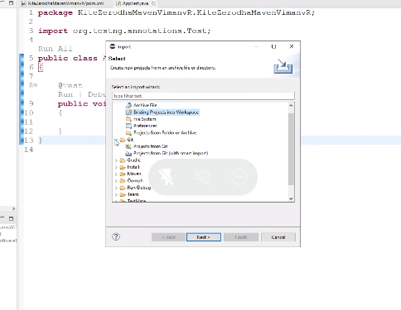

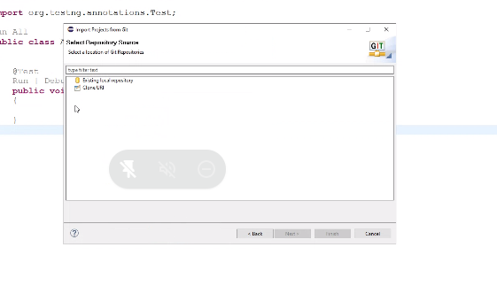

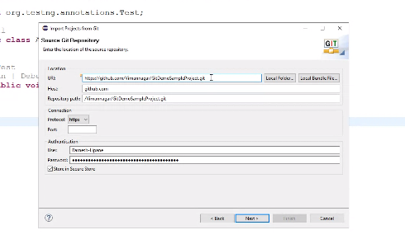

Pull process:

